Robotics 3
Portfolio Light Finder
Group Members 1
Main Task 1
Specification of Task 1
Specification of Sub-Tasks 1
Proposed Test Procedure 2
Design Drawings 2
Flow Chart 3
Software Source Code 4-5
Discussion of Test Results 6
Oppertunities for improvement 6
Conclusion 6

Group Members
Group name: Group E

Andrew Seaford UB No. 02005195
Ian Aubrey UB No. 02002362
Jonathan Rogers UB No. 02000233
Nick Hardman UB No. 03014084

Main task
Design and build a mobile robot that will have the ability to move towards a source of light and deal with random obstacles that may happen to be on the way.

Specification of task
- Design a base capable of carrying the weight of the robot
- The robot must have its own drive system
- The robot must be mobile
- The robot must be able the locate brightest light source
- Move towards the light source
- Be able to detect obstacles
- Avoid objects in path

Specification of sub tasks
- Design a base capable of carrying the weight of the robot
Base must accommodate for weight of all used components
- The robot must have its own drive system
The robot will have 2 motors powered by an onboard battery pack
- The robot must be mobile
The robot must have enough power to move forwards, backwards and be able to turn
- The robot must be able the locate brightest light source
This will involve taking multiple measurements of light and calculating which is the brightest
- Move towards the light source
When the brightest light direction is decided, the robot must move in that direction
- Be able to detect obstacles
The robot will use infrared detectors to detect objects in its path
- Avoid objects in path
If any object is in close proximity the robot will decide which way to go around it and follow the side of the object until it is no longer in the way

Proposed test procedure
- Place robot in empty arena 1 meter away from light source.
PASS TEST: after 30 second’s robot within 10cm of light source
FAIL TEST: after 30 second’s robot more than 10 cm from light source
- Place robot in arena with obstructions 1 meter away from light source.
PASS TEST: after 30 second’s robot within 10cm of light source
FAIL TEST: after 30 second’s robot more than 10 cm from light source

Design Drawings
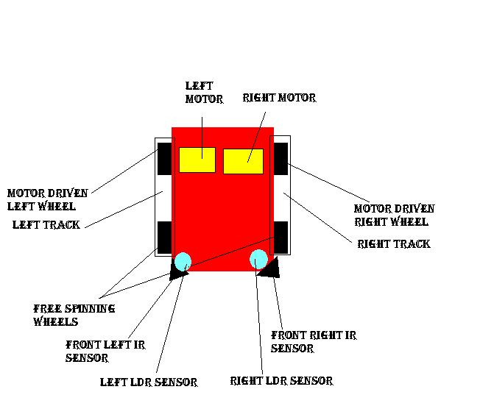

Flow Charts
Declare Variables
LDR tests
Infrared sensor tests
Nothing in front
Both Obstructed
Left only Obstructed
Left = right
More light on right
More light on left
Right only Obstructed
reverse
Turn right
Turn left
forwards
Calibrate light values

Software source code
void main()
{

float leftir=0.0;
float rightir=0.0;
float percentleft=0.0;
float percentright=0.0;
float plustenleft =0.0;
float plustenright=0.0;
float negtenleft=0.0;
float negtenright=0.0;

float tol =3.5;

int lightLeft =0;
int lightRight =0;
int lightLevel =0;

int i=0;
for (i=0;i<5;i++)
{
leftir=(float)lego0;
rightir=(float)lego1;

percentleft = 255.0 - leftir;
percentright= 255.0 - rightir;

printf("\n pl %f pr %f",percentleft,percentright);
printf("irl %f irr %f",leftir, rightir);

plustenleft= (((percentleft/100.0)*tol)+ percentleft);
plustenright= (((percentright/100.0)*tol)+ percentright);

negtenleft= (percentleft-((percentleft/100.0)*tol));
negtenright= (percentright-((percentright/100.0)*tol));

}

/* continous loop*/
while(1)
{
sleep(.1);/*pause o.1 secs*/

leftir=(float)lego0;/*left ir*/
rightir=(float)lego1;/*right ir*/

percentleft = 255.0 - leftir;
percentright= 255.0 - rightir;

printf("\n pl %f pr %f",percentleft,percentright);

printf("pl=%f ptl=%f",percentleft,plustenleft);
/*is there anything in front of robot?*/
if((percentleft < plustenleft) && (percentleft > negtenleft)&&(percentright < plustenright)&&(percentright > negtenright))
{
printf("\n Forward");
fd(1);
fd(0);
}
else
{
if ((percentleft > plustenleft) && (percentright < plustenright))
{
printf("\n Left");
fd(1);
bk(0);
}
if ((percentleft < plustenleft) && (percentright > plustenright))
{
printf("\n Right");
fd(0);
bk(1);
}
if ((percentleft > plustenleft) && (percentright > plustenright))
{
printf("\n Backwards");
bk(0);
bk(1);
}
}
lightLeft = analog(5);
lightRight= analog(6);

lightLevel = lightLeft - lightRight;
if (lightLevel < 10 && lightLevel > -10)
{
/*move forward*/
printf("\n forward");
printf("l=%d r=%d",lightLeft,lightRight);
motor(1,50);
motor(0,50);
}
else
{
if (lightLeft > lightRight)
{
/*Turn right*/
printf("\n right");
printf("l=%d r=%d",lightLeft,lightRight);
motor(0,50);
off(1);
}
if (lightRight > lightLeft)
{
/*turn left*/
printf("\n left");
printf("l=%d r=%d",lightLeft,lightRight);
motor(1,50);
off(0);
}
}

}

}

Test results
Test 1) The robot was within 10 cm of the light source

PASS

Test 2) The robot finished by continually driving into a shoe, away from light source

FAIL

Discussion of results
The Lego IR sensors fluctuate between 180 and 200.
They increase by 3 when an obstruction something is pressed against them.
They don’t respond to anything more than an inch away.

Opportunities for improvement
We could gear the robot so it drives faster
Increase ground clearance so it can get over small obstacles and up/down terrain.
Use a better IR sensor which isn’t affected by ambient light

Conclusions
The robot works but isn’t fine tuned but it works to some degree.

I think trying to resolve the problems whilst using the Lego IR sensors is a waste of time.

The sensors values for light depend highly upon the colour / reflectivity of the surrounding surfaces. This has to be brought into consideration early in the design phase

