Robotics 3

Portfolio Task 2

Group Members 1
Main Task 1
Specification of Task 1
Specification of Sub-Tasks 2
Proposed Test Procedure 3
Allocation of tasks 3
Design Drawings 4
Flow Chart 6
Software Source Code 6
Discussion of Test Results 11
Conclusion 11

Group Members
Group name: Group E

Andrew Seaford UB No. 02005195
Ian Aubrey UB No. 02002362
Jonathan Rogers UB No. 02000233
Nick Hardman UB No. 03014084

Main Task
The task is to design and build an autonomous robot that can turn a predefined amount and drive forwards a predefined distance to arrive at a given point with absolute accuracy.

Specification of Task
The task can be broken down into the following sub tasks.

Creating the robot – This stage will require careful assessment of all requirements, a design which incorporates these and assembly using Lego Technic.

Programming the precise turn – The robot will have to use shaft encoders to detect the vehicle’s turn distance and use this information to turn a predefined distance.

Programming the drive forward – The robot will have to use shaft encoders to drive forward the precise distance required

Specification of Sub-Tasks

Creating the Robot

This sub-task has many elements too it, these elements are listed below with their specifications.

Chassis
- Must be a platform to which further ‘modules’ can be added (such as rear mounted trolley wheel)
- Must contain ALL elements required to fulfil ANY task not just this one.
- Must be extremely sound of structure and be able to withstand the rigours of use without losing any structural integrity.
- Must be simple to modify and adapt to any future task.
- Must include shaft encoders on axles.

Creating a “turn sensor”
- Must take an exact measurement of the robots turn distance.
- Must find suitable place to mount this sensor in order to obtain best results.

Implementing shaft encoders to measure distance travelled
- Shaft encoders must be built into robot chassis to take a reading from the axles of the robot.
- Wheels must be uniform throughout robot
- Motors must perform as evenly as possible

Programming the precise turn

This sub-task must adhere to the following points in order to create a useful, practical solution.

- Program must accept an angle in degrees and produce a turn of sufficient magnitude to move the robot to that angle.
- Program must establish a ‘conversion rate’ for degrees to shaft encoder ‘counts’

Programming the drive forward

This sub-task must achieve the following points in order to fulfil our requirements. We expect to be able to achieve these or better with our final design.

- Program must accept a distance input in mm
- Program must move the robot from the start point to the finish point via the shortest, fastest route possible.
- Program must use the shaft encoders, arrive at a useful result and use this information to accomplish the task.

Proposed Test Procedure
To test this robot we will have to see how accurately we can measure the angles. To test this we will draw out predefined angles and distances then mount a pen on the front of the robot to see how accurately it draws them.

Both the physical robot and the software will need rigorous testing. The physical robot must be constructed sufficiently to withstand whatever situation it will be faced with. In this case the conditions will not be too extreme and so as long as the robot is constructed sufficiently well to manoeuvre around the course, it should be ample.

The software will need, in this case, to be uploaded to the physical robot to be tested. If the robot was to be undergoing more dangerous tasks then an emulator or a simulated virtual environment may be used. The software will need to be tested rigorously to check that the robot can deal with all eventualities. Our software is unlikely to conform to this strict standard, but should be more than capable of carrying out the tasks set.

The overall objective for this robot is to turn a predefined angle and then drive forward a set distance. Testing of this robot will mainly focus around the shaft encoders. We will firstly need to calculate the circumference of the wheel. This informs us of how far the robot will travel for every one revolution. We will then display the number of counts which the shaft encoders have recorded. From here we should be able to use the number of counts as a multiplying factor when we get assigned a distance.

A similar approach will be taken to calculating the number of counts per degree turned. This will then allow us to turn the robot to an accurate level.

In order to test the robot we will need to test each aspect of the code separately. We will do this by drawing out on paper the angle to be turned and the distance to be travelled. We will then correctly align the robot and allow it to run. The robot should then be lined up with the end of our mark.

This method of testing should show that all the code functions work individually. The final test for the robot will be placing it in the arena to check that it can accomplish the task correctly.

Allocation of tasks
It is impossible for the entire group to work on the same task at the same time so we split the group in half. One half worked on the program and the other, on the robot. At all times we made sure that we knew what the other half of the group was doing. Then if there was a problem which could not be easily solved we swapped jobs. This enabled us to bring new ideas and a fresh perspective whenever our progress slowed.
Often during this task we split the group so one half worked on the turning section and the other on the distance section.

Design Drawings
In this section our original design ideas will be accompanied by photographs of the finished product and an explanation of how / why it varies as well as an explanation of why we made certain decisions. Also proof that the product fits the specification will be provided in this section.

Chassis

The Chassis of our robot (see picture above) is very strong and well built (note the symmetry of the design). It has much potential and can / will be adapted to many different tasks. Unfortunately the photograph is stretched horizontally but it is still possible to see the strength inherent within the construction. Throughout our testing and general use the chassis never caused a problem. Although it took a long time and painstaking attention to detail to construct, we all feel it was worth the extra effort to fulfil each point of the specification so successfully.

Turn sensor
For the turn sensor we adopted a totally unique design idea. We found that the shaft encoders used on each axle were adequate for measuring the distance moved but were inadequate when it came to measuring the turn distance.

This image shows the shaft encoder (blue) attached to the axle of the robot.
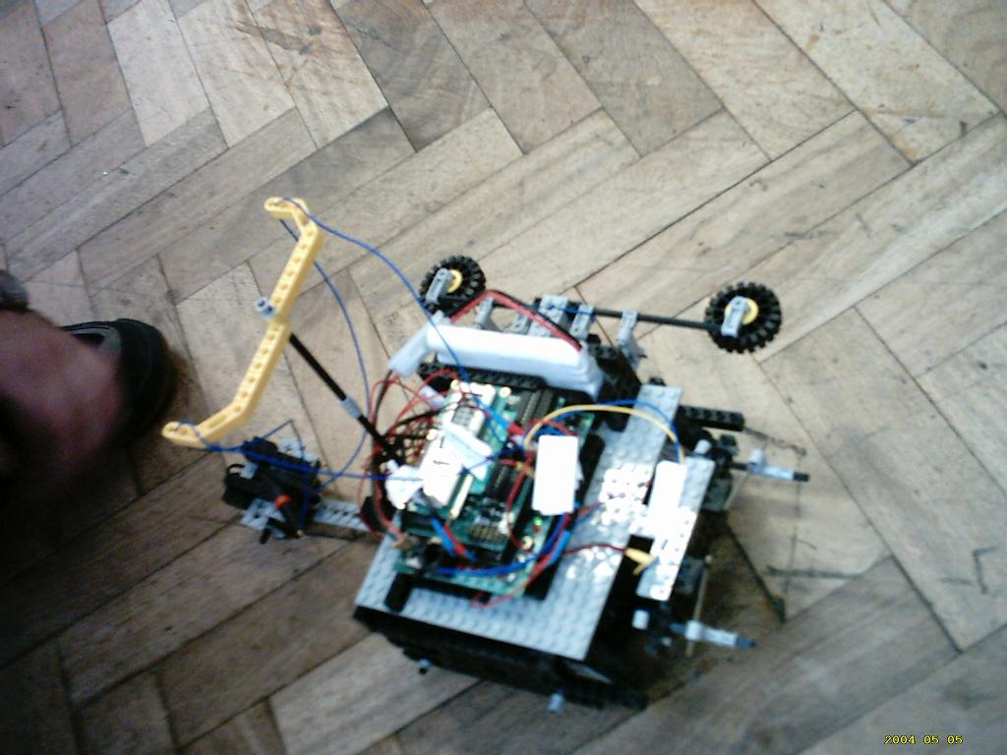

After some experimenting we realised that a shaft encoder mounted much further away from the centre of the robot’s turning circle gave much more useful results as it moved a lot further. We mounted a shaft encoder at the end of a long arm, making it act like a trolley wheel eliminated the possibility of error due to skidding.

Implementing Shaft Encoders
Two shaft encoders have to be built into the chassis to achieve this task. These are too measure the distance travelled in the second half of the task, two are required so allowances can be made for one side of the robot moving at a different speed to the other.
This image shows the shaft encoders mounted at the rear of the robot, connected directly to the axles.

Flow Chart
Start
Finish
Calculate angle and distance
Turn angle
Drive forward
Move backwards to compensate for overshoot

Software Source Code
When writing the program for the robot we uncounted some problem with the angle sensors. For some unknown reason when we attached many angle sensors to the robot we got strange measurements that we could not explain. The result of this was that we have written two different programs.

prog1.c - This program moves the robot forward a set distance. The robot is accurate to 0.5cm. This program uses two angle sensors attached to the back wheels of the robot to measure the speed of the wheels, to make sure that the robot drivers in a straight line.

/*Task 2*/
/*Group E*/
/*Andrew Seaford*/
/*Jonathan Rogers*/
/*Ian Aubrey*/
/*Nick Hardman*/

/*This program moves the robot forward a set distance. The robot is accurate to 0.5cm. This program uses two angle sensors attached to the back wheels of the robot to measure the speed of the wheels, to make sure that the robot drivers in a straight line.*/

void main()
{
/*The count increases by one every 22.5 degrees. This means that one full revolution of the wheel equals 16 counts*/
/*The diameter of the wheels is 81.6mm, So c=Pi*d => 3.14*81.6=256.35mm*/
/*The circumferance of the wheel is 256.35mm. Each count means that the robot has traveled 256.35/16=16.022122533308mm*/

/*declare variables*/
int distance=1000; /*Change this number to change the distance the robot moves in mm*/
int distanceCounts=0; /*The program converts the above distance to a number of counts and is stored in this varaible*/

int revolutionsLeft=0; /*number of revolutions on the left side*/
int revolutionsRight=0; /*number of revolutions on the right side*/
int speedL=0; /*speed of left motor*/
int speedR=0; /*speed of right motor*/
int endL=0;
int endR=0;
int ovrL=0;
int ovrR=0;

/*Calculate the number of counts*/
distanceCounts = distance / 16;
distanceCounts = distanceCounts *-1; /*The angle sensors have been built into the robot the wrong way around. so as the robot moves forward the number decreases.*/

printf("\nPress start button");
while(!start_button()){}

/*reset count sensors to zero*/
lego0_counts=0;
lego1_counts=1;

/*Start the robot moving*/
fd(0);
fd(1);

while(1)
{

/*Read values from sensors*/
revolutionsLeft=lego0_counts;
revolutionsRight=lego1_counts;

printf("\ncountL=%d countR=%d",revolutionsLeft, revolutionsRight);

/*Compare the speeds of the left motor and right motor.*/

if(revolutionsLeft == revolutionsRight)
{
/*Left and Right motors are rotating at the same speed*/
speedL=100;
speedR=100;
}

if(revolutionsLeft > revolutionsRight)
{
/*Left motor is faster than the right motor*/
speedL=70;
speedR=100;
}

if(revolutionsLeft < revolutionsRight)
{
/*right motor is faster than the left motor*/
speedL=100;
speedR=70;
}

motor(0,speedL);
motor(1,speedR);

if(revolutionsLeft==distanceCounts ||revolutionsRight==distanceCounts)
{
ao();
msleep(50L);
/*The robot may roll forward*/

endL=lego0_counts;
endR=lego1_counts;
ovrL=endL - distanceCounts;
ovrR=endR - distanceCounts;

printf("\ndis=%d l=%d r=%d",distanceCounts,endL,endR);

while(lego0_counts != (endL-ovrL))
{
motor(0,-20);
motor(1,-20);

}

ao();
sleep(50.0);
printf("\n%d %d",lego0_counts,lego1_counts);
/*finished*/
break;
}
}

}

prog2.c - This program turns a set angle and then moves forward a set distance, using one angle sensor attached to the trolley wheel at the back of the robot. This program did work, but for some unknown reason would not work on the day of demonstration.

/*Task 2*/
/*Group E*/
/*Andrew Seaford*/
/*Jonathan Rogers*/
/*Ian Aubrey*/
/*Nick Hardman*/

/*This program turns a set angle and then moves forward a set distance, using one angle sensor attached to the trolley wheel at the back of the robot. This program did work, but for some unknown reason would not work on the day of demonstration.*/
void main()
{
/*The count increases by one every 22.5 degrees. This means that one full revolution of the wheel equals 16 counts*/
/*The diameter of the wheels is 30mm, So c=Pi*d => 3.14*30=94.25mm*/
/*The circumferance of the wheel is 94.25mm. Each count means that the robot has traveled 94.25/16=5.89mm*/

/*declare variables*/
float distance=1000.0; /*Change this number to change the distance the robot moves in mm*/
int distanceCounts=0; /*The program converts the above distance to a number of counts and is stored in this varaible*/

int angle=90; /*Change this number to change the angle the robot turns*/
int angleCounts=0; /*The program converts the above angle to a number of counts and is stored in this varaible*/

int countsPer360=175;

int revolutions=0; /*number of revolutions*/
int end=0; /*these variables are used to calculate the overshoot, when the robot rolls after driving forward*/

int ovr=0; /*these variables are used to calculate the overshoot, when the robot rolls after driving forward*/

/*convert distance in mm to number of counts*/
distanceCounts = (int)(distance /5.89);
printf("\nd=%d",distanceCounts);

/*convert angle in degrees to number of counts*/
angleCounts=angle/(360/countsPer360);

printf("\nPress start button");
while(!start_button()){}

/*Turn*/
/*reset count sensors to zero*/
lego0_counts=0;

while(lego0_counts<angleCounts)
{
printf("\nturning angle=%d",lego0_counts);
motor(0,70);
motor(1,-70);
}

/*Drive forward*/
/*reset count sensors to zero*/
lego0_counts=0;

while(1)
{

/*Read values from sensors*/
revolutions=lego0_counts;

/*Start the robot moving*/
fd(0);
fd(1);
printf("\nrev=%d",revolutions);

if(revolutions >distanceCounts)
{
/*robot has moved set distance. The robot must now correct the distance taking into account the fact that when the motors stop the robot still rolls forward.*/
ao();
msleep(50L);/*wait as robot rolls forward*/

/*Calculate overshoot*/
end=lego0_counts;
ovr=end - distanceCounts;
printf("\ndis=%d l=%d",distanceCounts,end);

while(1)
{
motor(0,-20);
motor(1,-20);
if (lego1_counts != (end-ovr))
{
break;
}

}
printf("\n%d",lego1_counts);

/*finished*/
ao();
printf("\nFINISHED d=%d a=%d",distance,angle);
break;
}
}

}

Discussion of Test Results

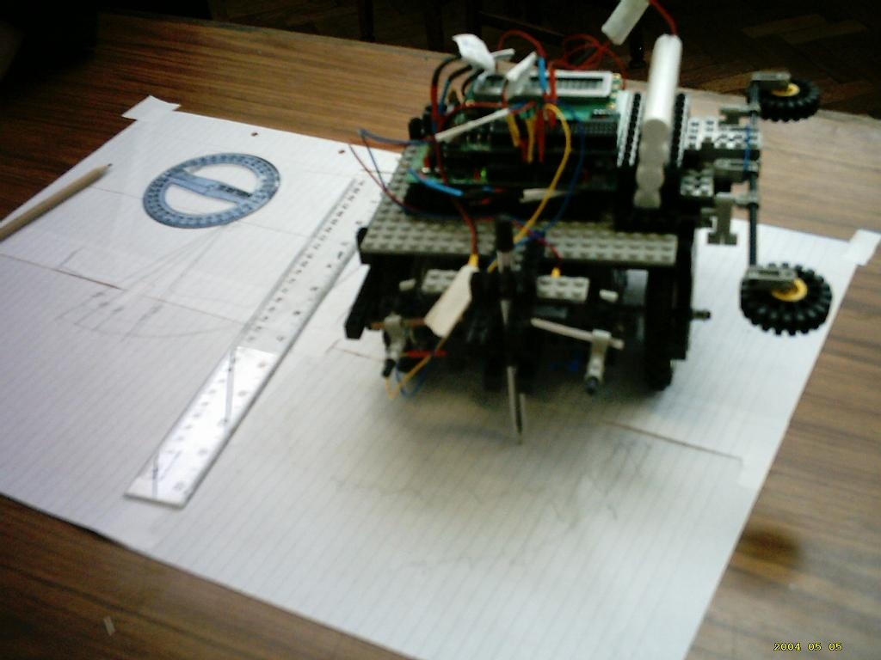
After creating the code we have tested the robot according to the testing plan set out previously. The photo on the right shows a pen attached to the front of the robot. After many permutations on the number of counts we finally decided that the robot would need modification to be able to accomplish the turning section of the task satisfactorily. We decided that we needed to get an exaggerated count reading for a more accurate result. To do this we constructed the trolley wheel. This proved to be much more successful as the count was not affected by the skid steer turn of the robot.

However, for measuring distance we found the most accurate result was obtained by allowing the robot to drive forward at full speed till it met the required distance, then waiting for a fraction of a second and reverse on the lowest speed until the perfect position is found. This method reached perfection because we corrected the problem of momentum. Once the robot reaches the correct position going forward, it cuts power to the motors. However because the robot does not have breaking, the robot still continues to travel for a time. This is then corrected by the slow reverse. We used our method because we found that the distance was achieved much faster and whilst thins was not in the brief we believe our product to be more effective with this modification.

Unfortunately, when the two perfections are combined we have problems. As we are required to turn then drive, the distance finding code failed. This was due to the trolley wheel not being able to travel in reverse. After some careful measurements, we concluded that the best results would be gained by using the trolley wheel, and removing the reversing sequence in the distance code.

After carrying out each of the tests we were able to make slight adjustments to variables within the code, however this was not always necessary and was only implemented out of a desire to achieve perfection.

Conclusion
During this task we tackled several previously un-experienced problems; using shaft encoders and controlling the robot with such a degree of precision. Both were solved before the deadline and the demonstration was all set. However prior to the demo we encountered a mysterious problem. We were able to solve this program and show the robot working perfectly. The un-orthodox turn sensor and the speed at which the whole movement is carried out make this a very successful project.

